Kerry McGowan

Student ID: 11552642

HW #1

Paths, Folders, Directories (pwd)

55.3.1 Do This

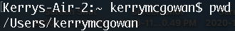

55.3.3 Do More

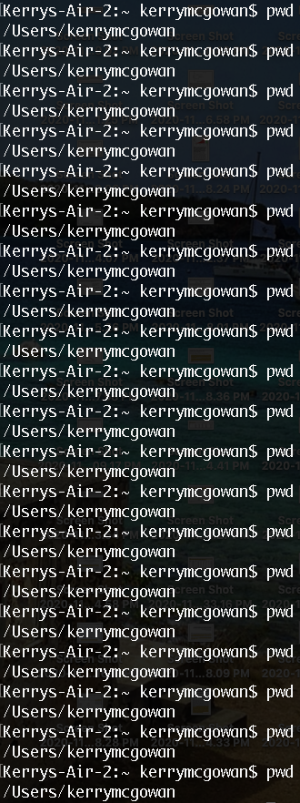

If You Get Lost

55.4.1 Do This

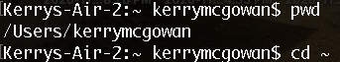

Make a Directory (mkdir)

55.5.1 Do This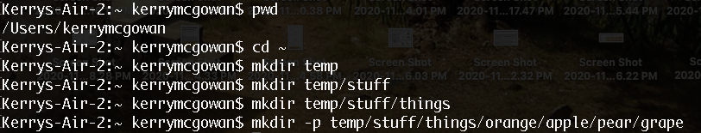

55.5.3 Do More

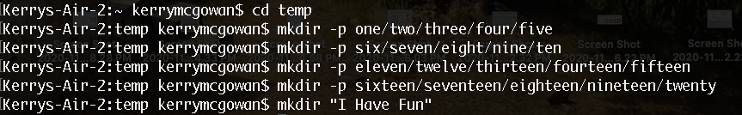

Change Directory

55.6.1 Do This

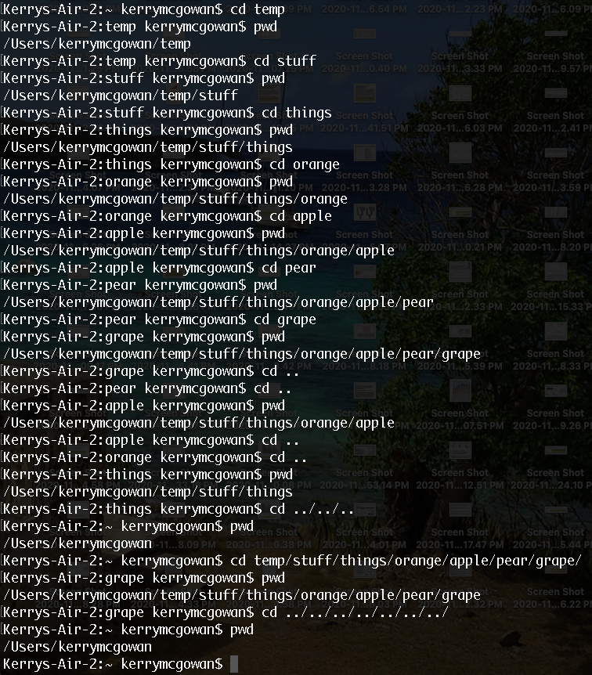

55.6.3 Do More

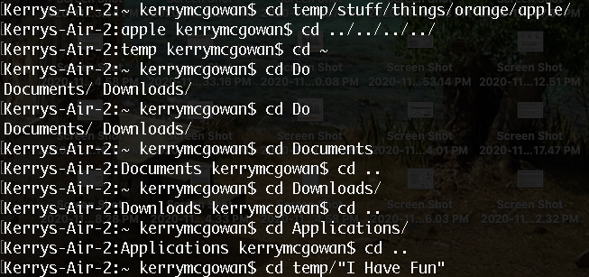

List Directory (ls)

55.7.1 Do This

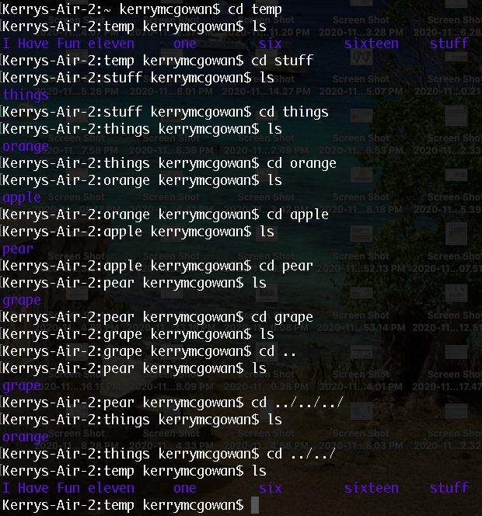

55.7.3 Do More

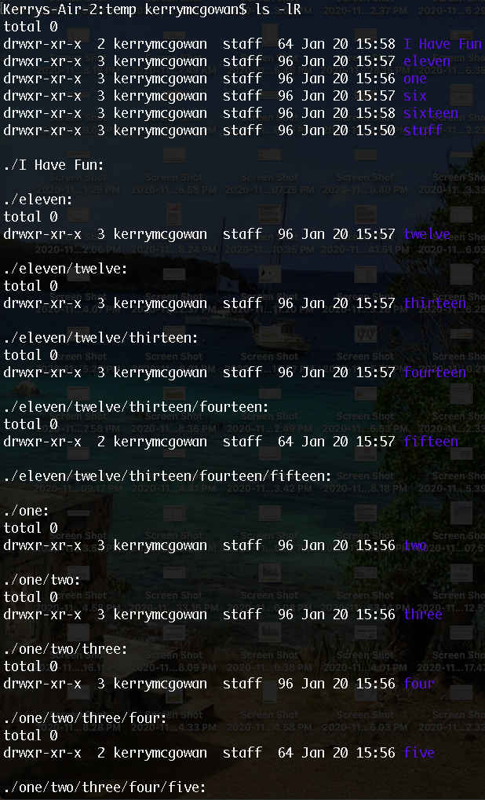

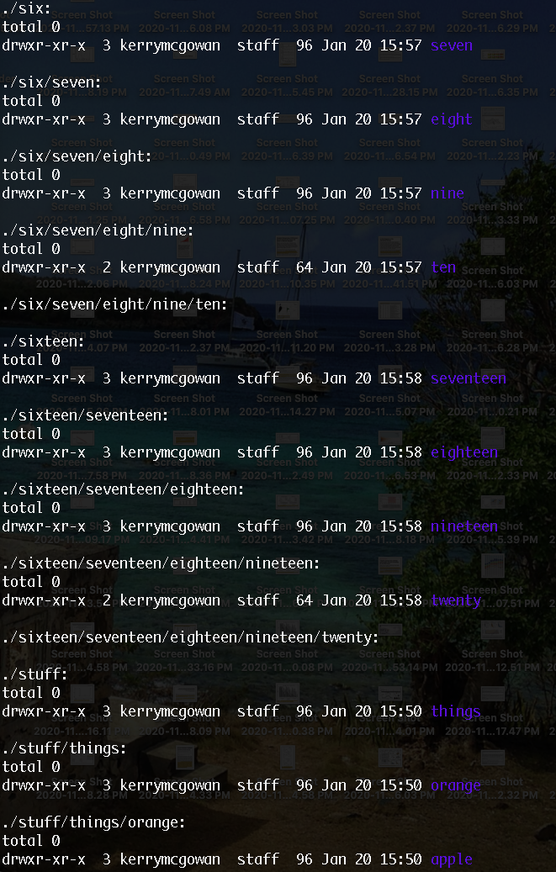

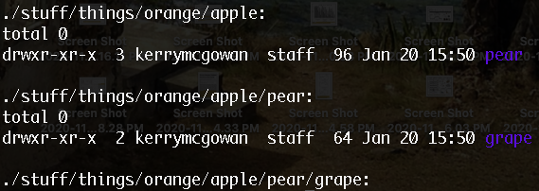

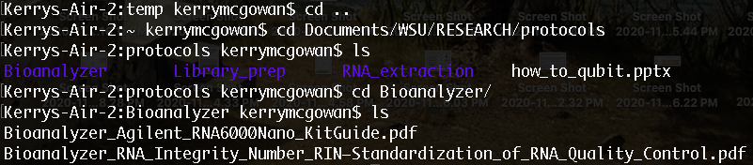

Remove Directory (rmdir)

55.8.1 Do This

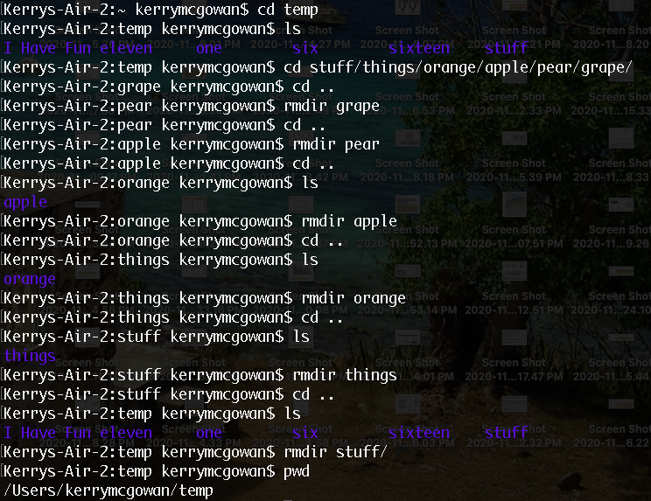

55.8.3 Do More

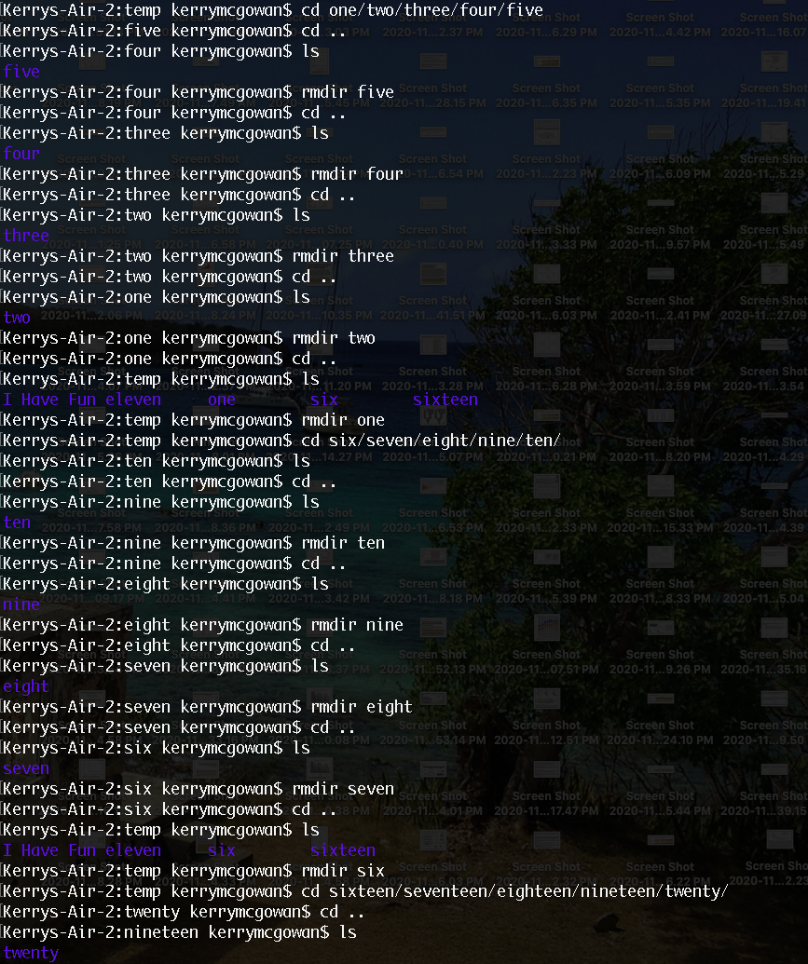

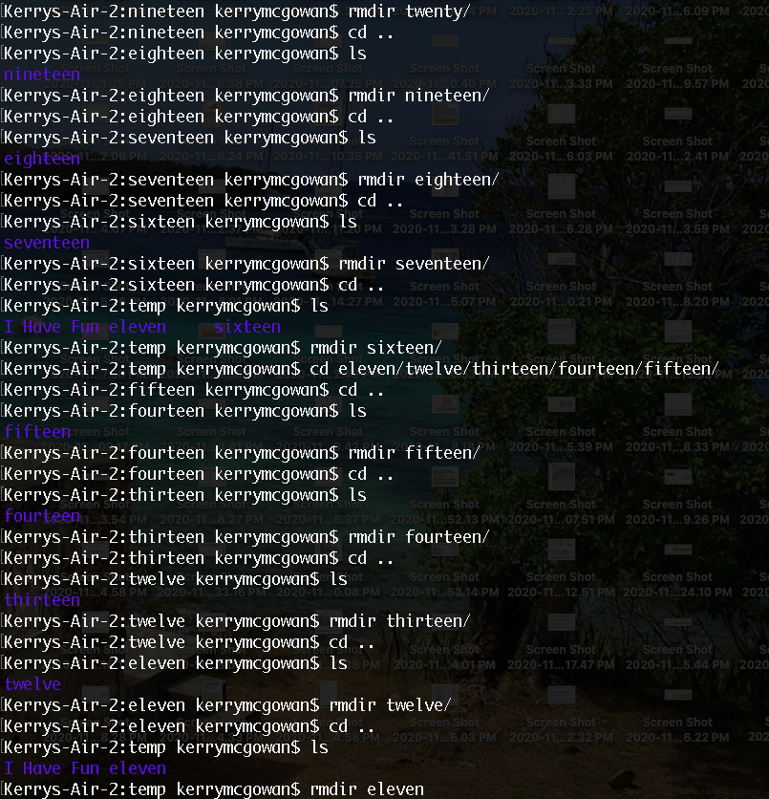

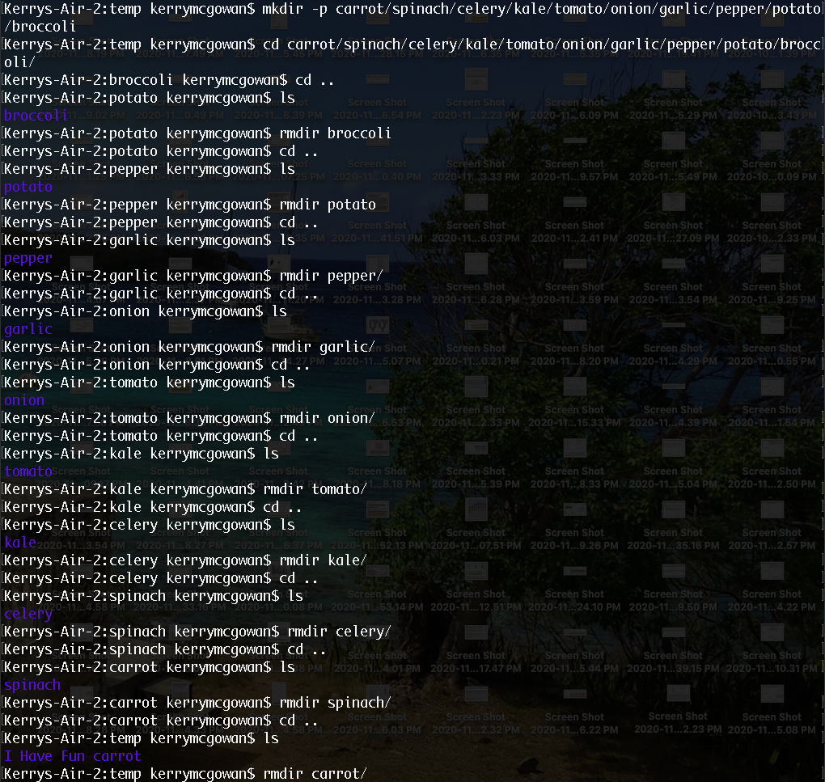

Moving Around (pushd, popd)

55.9.1 Do This

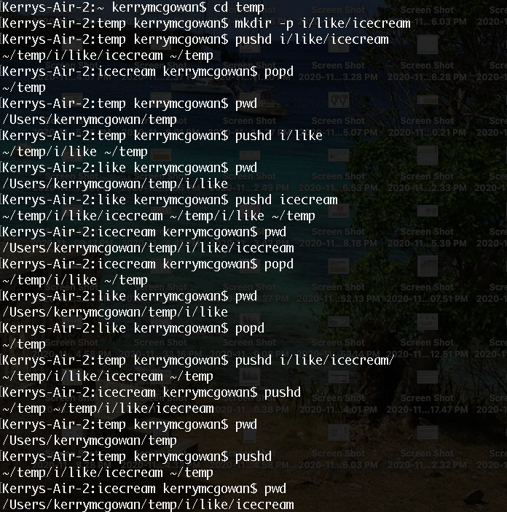

55.9.3 Do More

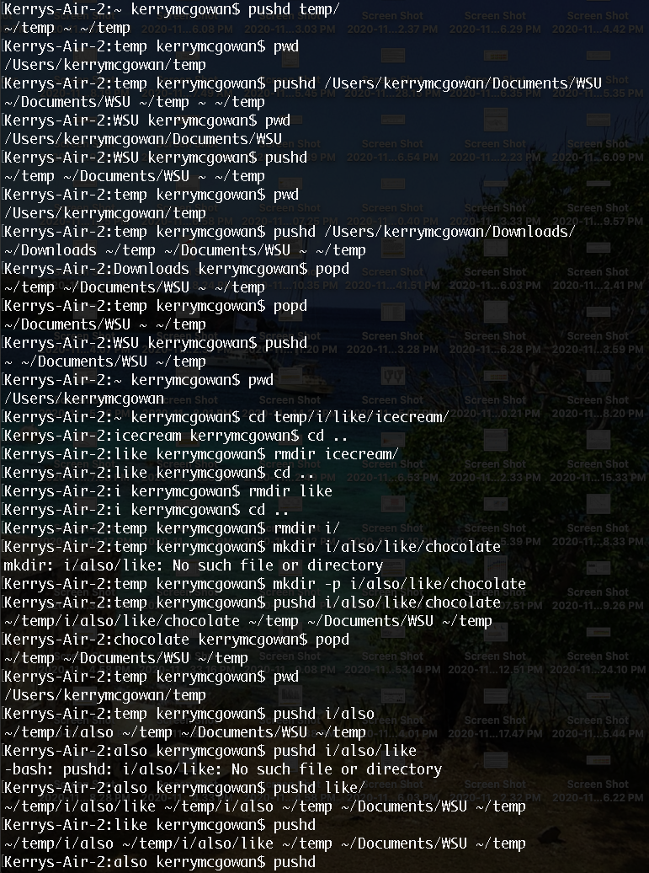

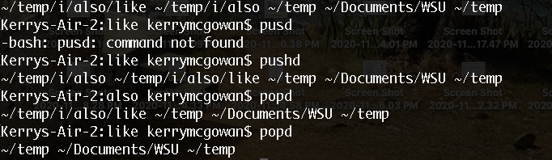

Making Empty Files (Touch, New-Item)

55.10.1 Do This

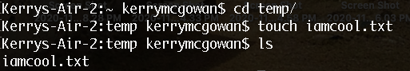

55.10.3 Do More

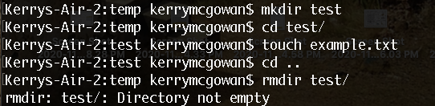

Copy a File (cp)

55.11.1 Do This

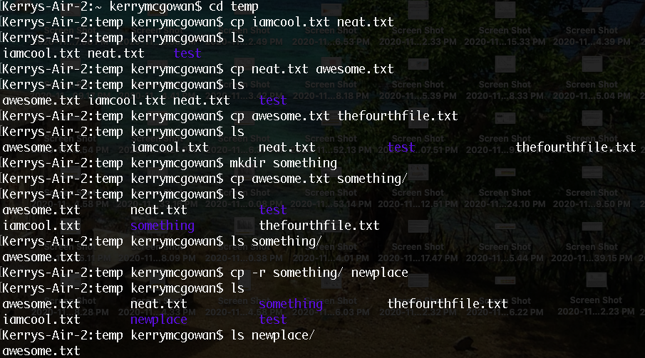

55.11.2 Do More

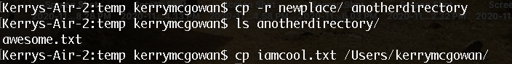

Moving a File (mv)

55.12.1 Do This

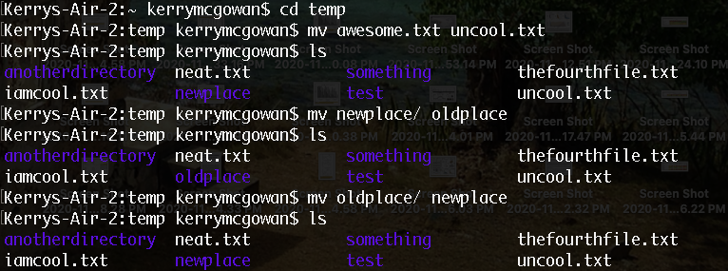

55.12.3 Do More

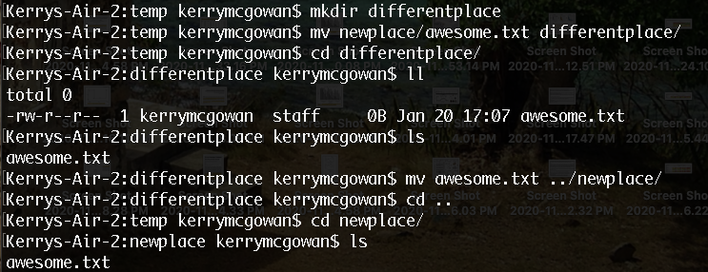

View a File (less, MORE)

55.13.1 Do This

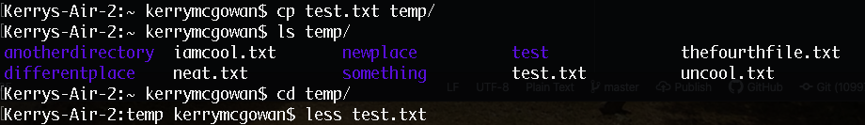

55.13.3 Do More

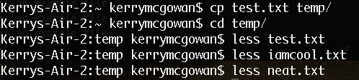

Stream a File (cat)

55.14.1 Do This

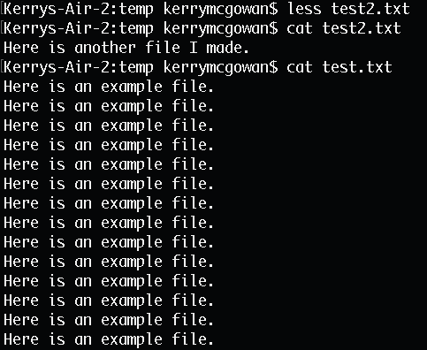

55.14.3 Do More

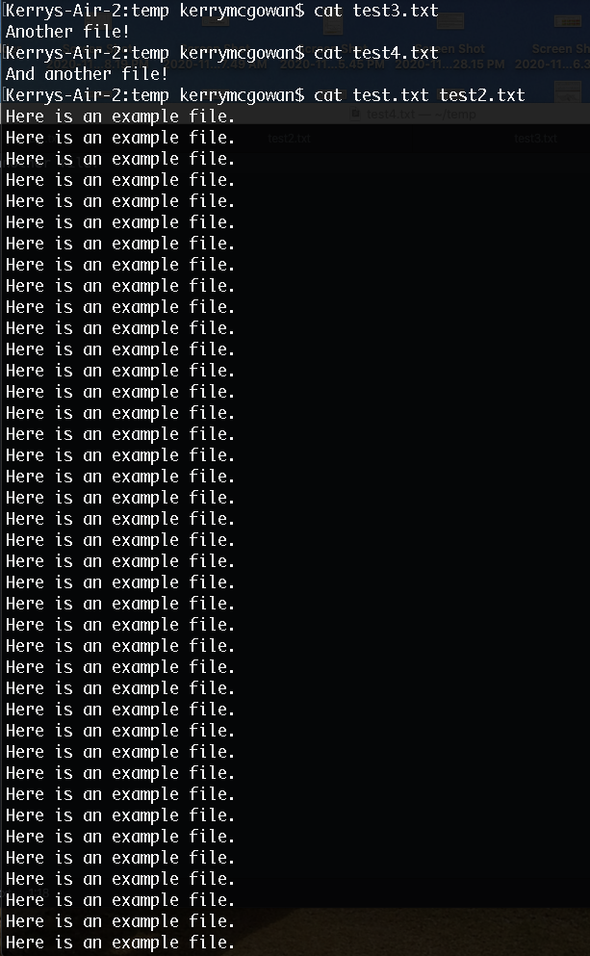

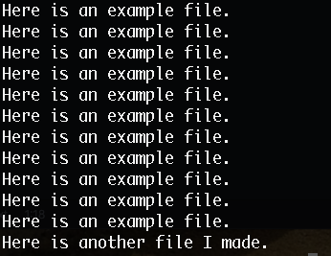

Removing a File (rm)

55.15.1 Do This

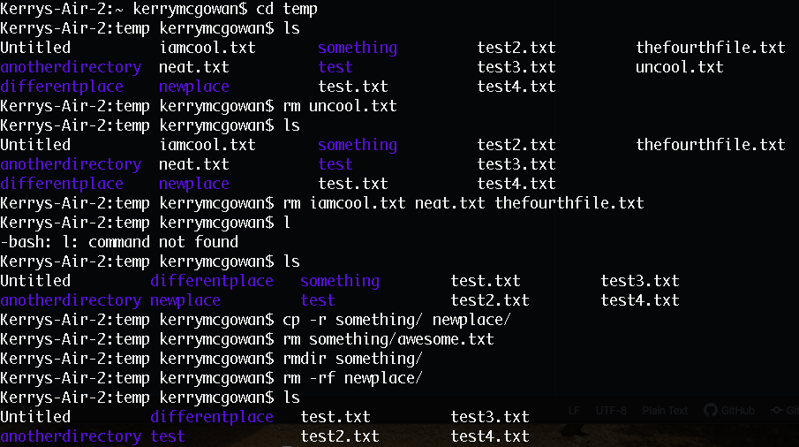

55.15.3 Do More

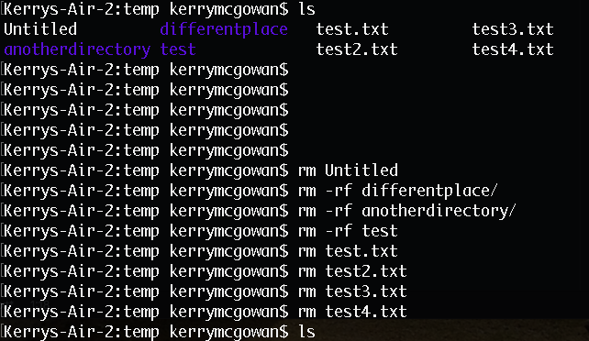

Exiting Your Terminal (exit)

55.16.1 Do This

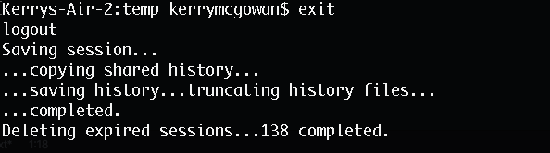

55.16.3 Do More

* xargs – takes standard input and executes commands on that input

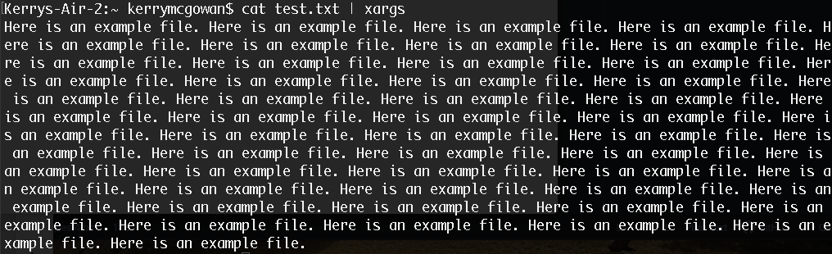

* sudo – allows a user to run programs with root privileges, stands for “superuser do”



* chmod – changes permissions of a file or directory

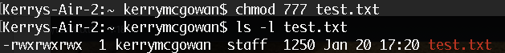

* chown – changes the owner of a file and group

